CARE INDIA FOUNDATION NGO

## Welcome To Care India Foundation NGO :: Helping For Children Education :: Helping For Poor FamilyCare India Foundation is dedicated to improving the life of neglected children and remote communities in India. We are associated with different activities like Medical treatment, Education, Protecting children from hazardious labour exploitation, Participate and help in making the world a better place to live, Motivating the youth in remote communities to earn their livelihood.

**We believe are the areas of greatest need and deserve to be the foci of our attention. We believe the three are inter-related fields and together the only way to make a sustainable and impactful difference in the benificiary population.  
A happy, healthy and creative child whose rights are protected and honoured in a society that is built on respect for dignity, justice and equity for all.**

**CARE INDIA FOUNDATION is a NGO (Non-Profit Organization) established with the pledge to help needy Underprivileged Children, parentless children, women and children belonging to vulnerable families. It is our vision that all such needy children should be given an opportunity to get Education, Medical & Emotional Care All the Help and Support should be reached to every Underprivileged children. CARE INDIA FOUNDATION are having various Programs for children who are in need of Education and Health care. These Programs are designed to support our main Programs such as:**



## What we do?

Care India Foundation focuses on providing education, development, intervention, treatment, dignity, care and a lot more to the needy and underprivileged children. Recognizing, understanding and implementing the best practices in child development, care and protection is a major focus of our programmes.  
  
**Vision** Our Vision is, to reach the maximum needy, to be in reach of all the needy, be the most sought for, recognized and admired organisation, supporting the overall development of underprivileged children

**Who We Are**

CARE INDIA FOUNDATION is managed by a board of Advisors comprising individuals from diverse backgrounds and expertise. The board is formed for a period of one year and a few independent members of eminenece and reputation are nominated each year. Members of this board meet once after quater.

**Vision and Mission**

CARE INDIA FOUNDATION is to empower underprivileged children, youth and women through relevant education, innovative healthcare and market-focused livelihood programs. We believes that unless members of the civil society are involved probalively in the process of development, sustainable change will not happen.

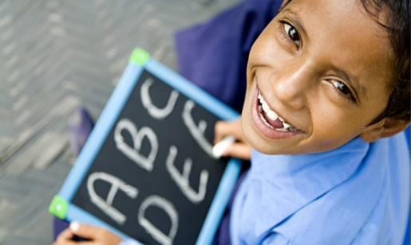

##### [We Care](https://wecareindiafoundation.org/about.html)

❯   In a land of green, we hope to bring in sustainability

❯   In a land of freedom, we hope to bring in responsibility

❯   In a land of opportunity, we hope to bring in equality

❯   India. We care.

We Care Foundation was set up in 2014 with a vision for community development in various spheres of life in India.

Whether in terms of technology, science or economics, India is a nation that is progressing at breakneck speed, but in that pace, are matters of matter of urgency as well – health, the environment, child safety and women’s empowerment – which are falling by the wayside, reduced in vision to nothing more than a blur.

At the We Care Foundation, we stop, we see, we listen. Which is why we are now taking action. The We Care Foundation is hoping to work at the grassroot as well as governmental levels to foster growth and development in India, primarily looking at the areas of health care, environment, and community service.  
Safe cities. Clean cities.

Educated communities. Empowered communities.

Clean environments. Healthy environments.

We Care foundation is a registered society under Societies Registration Act 1860 All the profits of the event proceeds to the WE CARE Foundation for charity work. Please draw cheque in Favor of the foundation, we do not accept cash.

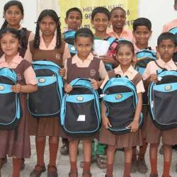We Care. We hope you do too.

Trinity Care Foundation has been implementing healthcare initiatives for the underprivileged sections of the society since 2007 in Karnataka State, India. At Trinity Care Foundation we believe in the future of our children – charity is just one of the many avenues we use to make the joy visible through the smiles of our nation’s children.

Trinity Care Foundation is led by a Team of Doctor’s and Public Health Professionals with focus marginalized sections of the society in Karnataka state, India.

You could start Corporate Social Responsibility (CSR) Initiatives for your Company in association with us.Partnering with Trinity Care Foundation charity in India will prove to be truly rewarding and even more so for the children and families that you will positively impact with your generous donations. Every little life you affect is a smile won and worn on the face of a beautiful child with a future filled with many more.

CSR Projects managed and implemented in Karnataka State, India

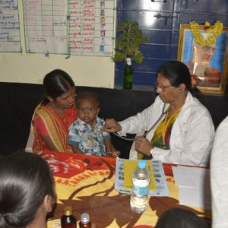

## Empowering marginalized girls through quality education and leadership skills

CARE India’s ‘Girl Education Program’ (GEP) has been working for 25 years to ensure quality elementary education for children, especially girls and those from marginalized communities, to help them become the leaders and changemakers of the future. We see education as an imperative tool for girls to realize their maximum potential by gaining crucial skills and dispositions that set them on the path of social and economic empowerment.

Our girls education programmes and projects in India work through building learning ecosystems that are inclusive, gender conscious, and safe for all. We work with various stakeholders to champion the importance of girl child education and mobilize resources through [online donations in India](https://www.careindia.org/donate/) and other strategies. Our education initiatives work in accordance with the Right to Education Act (2009) and National Education Policy 2020.

## Kilkari Care Foundation | Delhi